Initial idea

I started to consider some ideas for what I wanted my generative art to do. Whilst doing some light scamming on the internet for some inspiration I came across spirographs and decided that they could work well for the project. I then opened photoshop and started creating some to make sure I was happy with the idea and to get a feel for how they worked and looked.

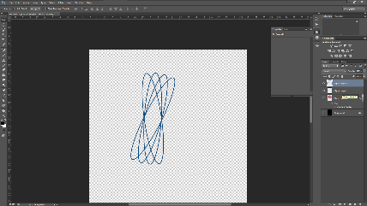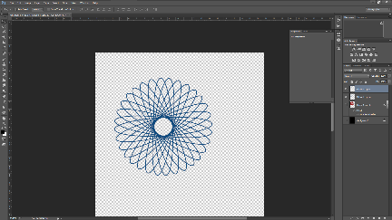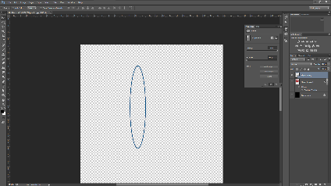

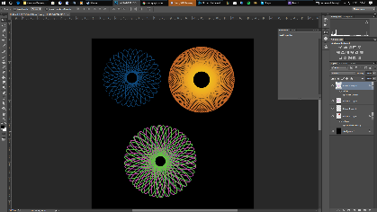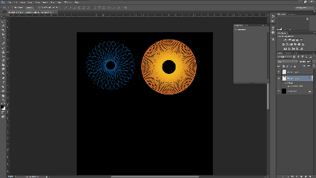

Inspiration

1. <http://codedoodl.es/_/gwenvanhee/pulsator/>

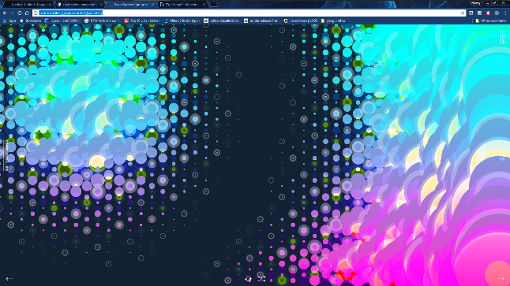

I found this piece interesting as it features a lot of interaction with the viewer with both mouse location and clicks. I liked the idea of this interaction as I thought this engages the viewer well and this is something I would like to implement into my project as it creates a feeling of a more unique experience every time.

1. <http://codedoodl.es/_/gwenvanhee/codebrush/>

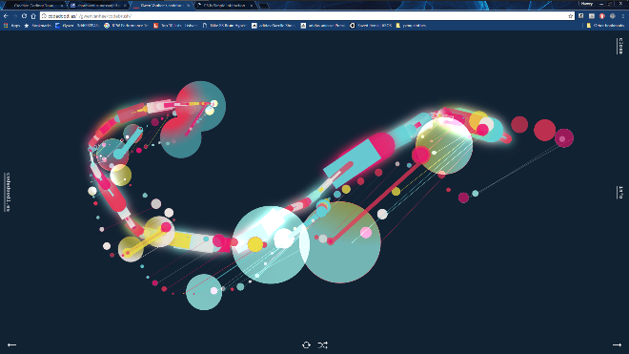

This work used more randomisation which I really like as once again adding some more random factors makes the art more original and I liked the idea of making something that couldn’t be replicated again. I also like the simplicity in this which makes it easy to use and not over complicating the art.

1. 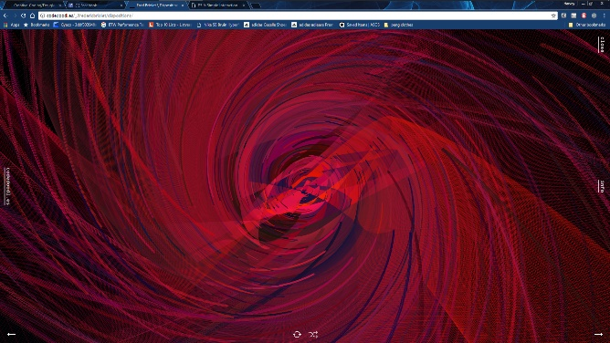<http://codedoodl.es/_/fredericbriolet/dispositions/>

I liked this design as it was different from the rest as it had less interaction and random variable however it still makes you feel like the art is vert unique. Also, it uses rotation as a way to make art which I really liked the idea of and is something that is not used as often.

Development

When developing my project my first idea was to make it so when the user clicks the mouse it would place a spirograph of varying; colours, dimensions and number of ellipses making the spirograph which would make it either more or less compact. However, after some review and testing I found that this was not as visually pleasing as I wanted it and I thought that the design lacked interest and captivation as there was not all that much variation in the pattern which made it rather boring along with the aesthetic being rather ugly. Over all I was not happy with the project.

I wanted to refresh my project still sticking with the same core idea of spirographs but add elements that made the design more fun to use. I wanted the art to be a lot more random giving the user a feeling of originality. To do this I made it so that when the user moves the mouse it changes the dimensions and shape of the spirograph drawing them around the canvas. This allows the user to create some truly unique patterns with the spirographs and make art that draws the eye in. I also added the functionality to change the colour of the spirographs to a random RGB value with a mouse click which deepens both the experience and art.

A small downsize to this design is with the spirographs being constantly drawn the art may be lost or overcomplicated so if I was to do this again I would add a way to pause the spirographs being drawn as you move the mouse.

https://github.com/HarveyBond/CreativeModule